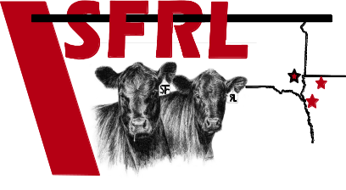
Sioux Falls Regional Livestock
PO Box 39
Worthing, SD 57077
605.372.8000 Phone
605.372.8004 Fax

email form to: Affidavit# ____________
office@sfrlinc.com (For Internal office use only)

CONSIGNOR/LIVESTOCK OWNER’S CERTIFICATE
The undersigned consignor/livestock owner:
- Delivers livestock to be sold at public auction in accordance with this market’s usual customs and practices.
- Represents that there are no liens on any of the livestock except as the undersigned has disclosed to the market; _________________________________________(ex: bank)
- Certifies that to the best of his/her knowledge, none of the livestock are adulterated within the meaning of the Federal Food, Drug & Cosmetic Act (e.g., none of them has been fed any feed derived from mammalian tissues as prohibited by 21 C.F.R. 589.2000 nor are they contaminated with foreign materials, nor do they have illegal levels of drug residues);
- Certifies that neither the undersigned nor the person(s) from whom the consignor purchased the livestock are on the USDA/FSIS active list of repeat violators as having had more than one residue violation in the past 12 months or if they are on the USDA/FSIS list that the consignor has identified the animals being sold that come from the person whose name appears on the USDA/FSIS list.
- Attests through first-hand knowledge, normal business records, or producer affidavits(s) that all livestock referenced by this document or other communications specific to the transaction and transferred are of ____US ORIGIN or _____ CANADIAN ORIGIN
or ___MEXICAN ORIGIN (check which box applies) and that should the origin of the livestock become other than that described above, the undersigned will notify the buyer/agent when this occurs; and
- Acknowledges that the consignor of livestock is responsible for payment of any veterinarian bills and disposal charges that arise if any of his/her livestock become non-ambulatory while at the market.
- If a freight invoice is submitted to the market, I authorize the market to make payment on my behalf to person/persons who haul my livestock to this market and to deduct an amount equal to such payment from the sales proceeds of my livestock.
This certificate/declaration/affidavit shall remain in effect until the undersigned delivers written notice of revocation to the market.
_____________________________________________ ________________________________________
Name of consignor (printed or typed) Signature of consignor

______________________________________________ ________________________________________
Address City/State/Zip
______________________________________________ ________________________________________
Date Cell Phone
__________________________________________________________________________________________
Email
Please email or mail to address above or fax to 605.372.8004

