SIOUX FALLS REGIONAL LIVESTOCK
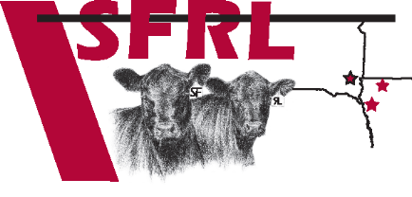28168 Commerce Ave – PO Box 39
Worthing, SD 57077
Phone 605.372.8000 Fax 605.372.8004
www.sfrlinc.com
DRUG FREE AFFIDAVIT
I, ________________________________________, certify that the livestock included in this shipment:
- From birth, have NEVER received supplemental hormones, growth performance hormones, and steroids of any kind in the feed or via implant.
- From birth, have NEVER received any Antibiotics, including Coccidiostats and Ionophores, either therapeutic or sub therapeutic.
Examples of Sub Therapeutic Antibiotics but not limited to: Aureomycin & Terramycin.
Examples of Coccidiostats & Ionophores but not limited to: Decoxx, Bovatec & Rumensin.
- From birth, have never been fed any animal byproducts.
- Are of US Origin (born and raised in the U.S.A.)

- Cattle delivered are Angus/Angus Cross Breeds

- Cattle delivered are: 51% Black ________ Color ________

By following good animal husbandry practices, all animals have been treated according to humane handling requirements.
CHECK ONE WHICH APPLIES
Original Producer __________ Grower/Backgrounder __________ Farmer/Feeder __________

Total Head Count __________ (Steers) __________ (Heifers) __________

Signature: _____________________________________________ Date ___________________________
Print Name: _________________________________________ Phone # ____________________________
Company Name (if applies) __________________________________________________________________
Address: _______________________________ City ___________________________ State ______ Zip ______
Completed form can accompany cattle, fax 605-372-8004 or email to: office@sfrlinc.com
Persons willingly making false statements, fictitious or fraudulent statements or entries regarding the above bullet points shall be liable for any damages due to inaccuracy of this certification.

